**BOARD OF DIRECTORS**

**2018-2020**

**Elena Garcia**

Manatee County

President

**Maria Longa**

Polk County

President-Elect

**Sharyn Foster**

Polk County

Secretary

**Diane Dannemiller**

Hernando County

Treasurer

**Myca Chandler**

Walton County

Region 1 Vice President

**Joe Adkins**

Columbia County

Region 2 Vice President

**Helen Christian**

Sumter County

Region 3 Vice President

**Brian Schultz**

Pasco County

Region 4 Vice President

**Celia Elrod**

Palm County

Region 5 Vice President

**Leticia Roman**

Volusia County

Past President

**Yvonne Johnson**

St. Lucie County

Past-Past President

Scholarship Chair

**Dr. Maria Pouncey**

Panhandle Area

Educational Consortium

(PAEC)

Board Appointee

**Marjorie Murray**

Seminole County/ECTAC

Board Appointee

**Kathi Harmon**

Seminole County/ECTAC

Webmaster

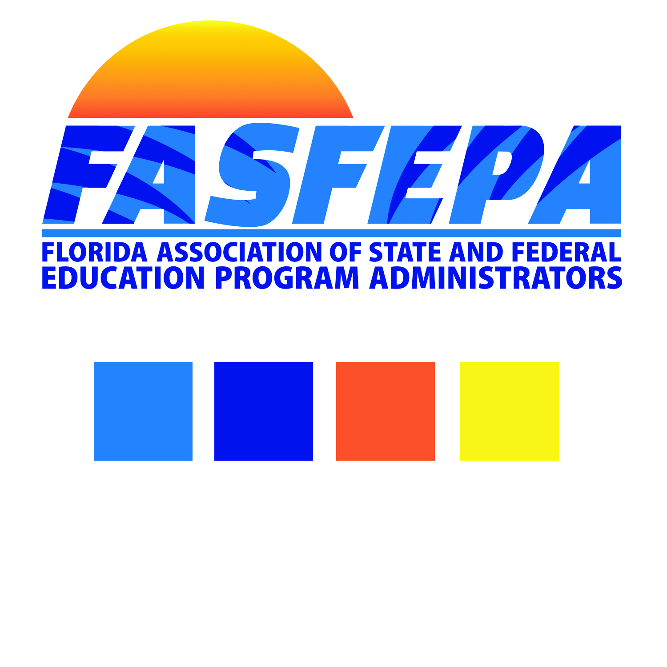

REGION I, II, III, IV and V – FASFEPA Vivian Scott Scholarship

**SCORING CRITERIA WORKSHEET** - ***Total: 100 + Points***

Applicant’s Name: ________________________________

**GPA - 40** Points possible:

4.0+ = 40 points

3.8 – 3.9 = 35 points

3.6 – 3.7 = 30 points

3.5 – 25 = points

3.3 – 3.4 = 20 points

3.0 – 3.2 = 15 points

**Honors or Advanced Placement courses - add two points for each course.**

**Total Points Florida GPA**: _______________________

**Activities, honors, awards (Athletics, Debate, Dramatics, Music, Publication, Student Government, Service to School and Community, etc.)**

Officer in club or organization - 2 points

Member of club or organization - 2 points

Athletics - 2 points sport

Variety - 2 extra points

Homeless – 1 point

Migrant -1

**Maximum - 10 points for Activities, honors, awards**

**Total Points for activities, honors, awards: ______________________**

**Essay - Maximum - 30 points**

**Total Points for Essay: ________________________________**

**Letters of Recommendation/Official Transcript -** Judgment decision **- Maximum - 10 points**

**Total Points for Letters of Recommendation/Transcript: ____________________**

***Grand Total: _________________________***

FASFEPA is an affiliate of The National Association of Federal Education Program Administrators