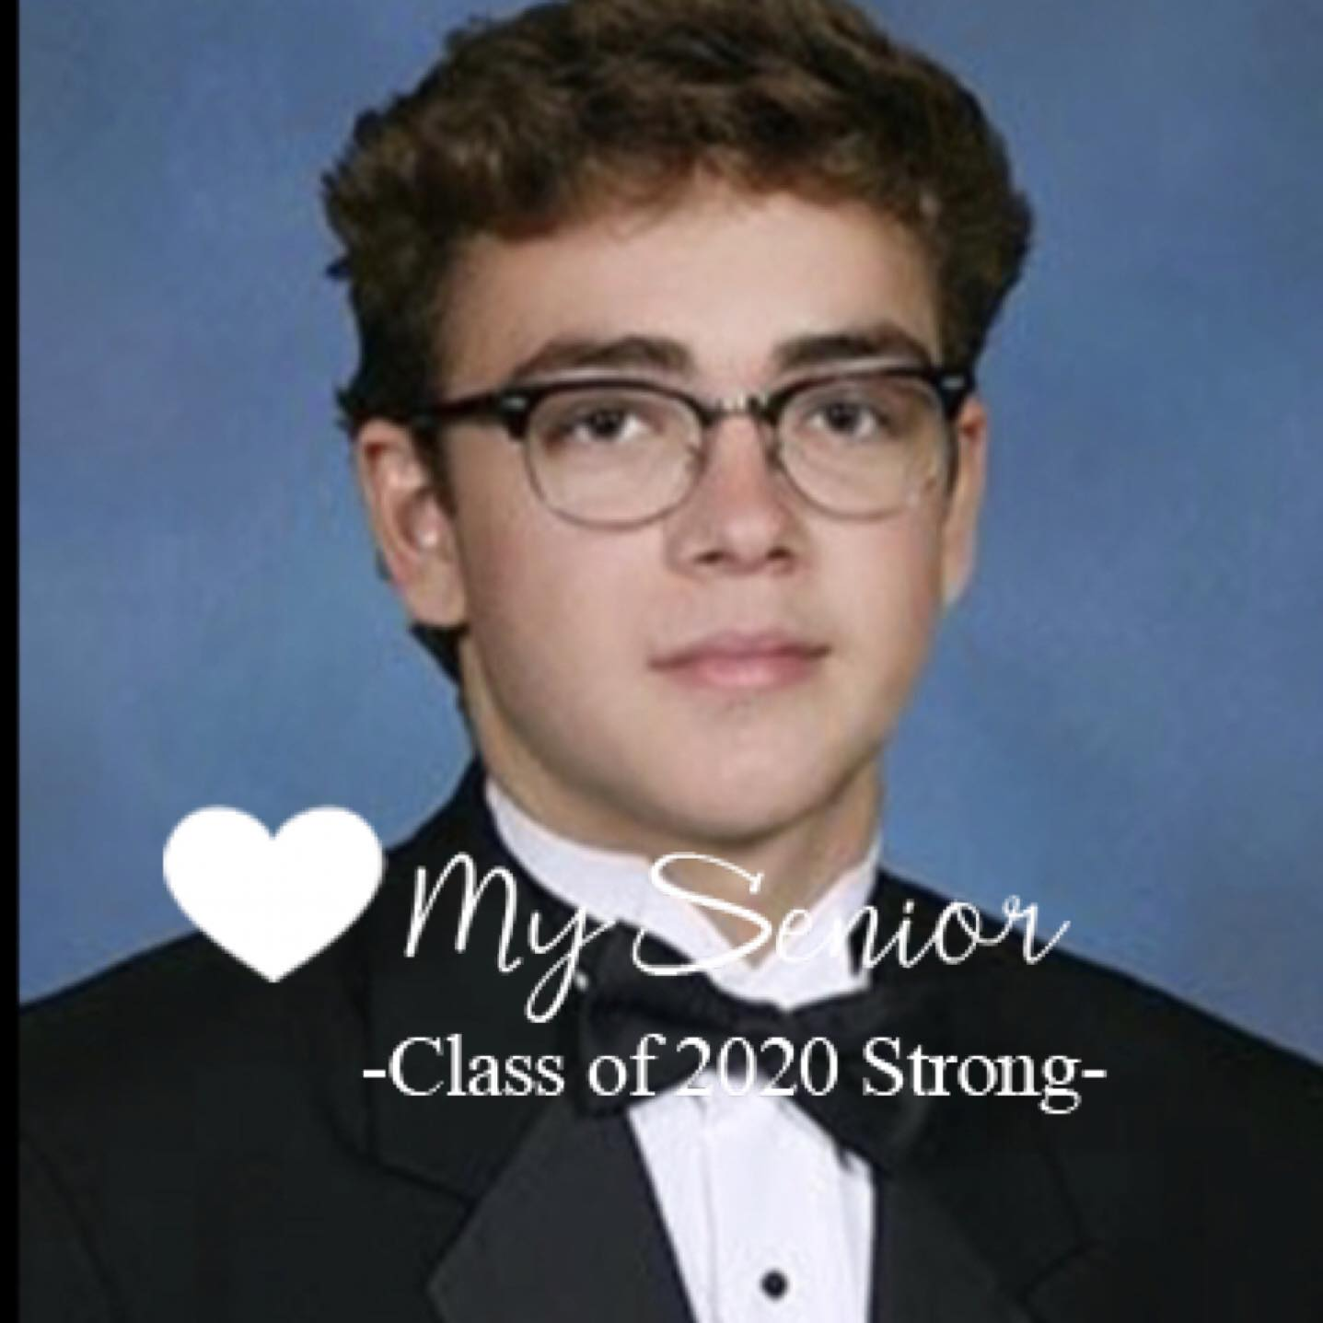
The Jack Hamilton Wheeler Memorial Scholarship
We are pleased to announce the opening of the application for the Jack Hamilton Wheeler Memorial Scholarship.

This scholarship was founded in 2019, when Jack, who was a senior at Creekside, lost his life in a tragic car crash three days before Christmas. To honor Jack‘s memory, life, and legacy at Creekside high school, the Wheeler family has established a scholarship foundation to provide financial assistance to graduating St. Johns County high school seniors pursuing higher education.

Jack was very passionate about his academic success and would be very pleased to know that his family is able to be of help to others making their continuing academic dreams into a reality.

Three scholarships will be awarded in the amounts of $2,000 $1,500 and $1,000 for students pursuing college and/or vocational school enrollment in the year of 2022.

Your main point of contact at INK is Donna.Lueders@stjohns.k12.fl.us. The Application deadline to your guidance counselor is April 30, 2022. However, this is subject to each school individually. Please inquire at your guidance office.

Application Criteria:
- 3.0 Minimum GPA Requirement
- Minimum of 125 community service hours
- Clean disciplinary history
- Involvement in at least 2 extracurricular activities (ie. Clubs, Sports, Band, etc) - Two essays of at least 500 words each (Prompts below)
Applicant:
- Name____________________________________________________________________________
- School/Graduating Class_________________________________________________________ - Email____________________________________________________________________________
- Phone____________________________________________________________________________
- Address__________________________________________________________________________
- Clubs/Teams_____________________________________________________________________
- Please list your top 3 school choices to which you have been accepted, along with the major/degree program you intend to choose o 1) o 2) o 3)
Supporting Documents: Please attach a copy of the following documents along with this application
- Resume/Biography (Optional)
- Grade report (i.e. Unofficial Transcript)
- Proof of Community Service Hours (Optional)
- Any letters of recommendation (Optional)
- 2, 500-word essays
Essay Topics: (500 words per)
- Describe the importance of family in your life.
- What does giving back mean to you?

